**ATTRIBUTES OF GERMAN CREDIT DATASET**

1. Attributes list and their type:
   * Checking_status – Nominal
   * Duration – Numeric
   * Credit_history – Nominal
   * Purpose – Nominal
   * Credit_amount – Numeric
   * Serving_status – Nominal
   * Employment – Nominal
   * Istallment_commitment – Numeric
   * Personal_status – Nominal
   * Other_parties – Nominal
   * Residence_since – Numeric
   * Property_magnitude – Nominal
   * Age – Numeric
   * Other_payment_plans – Nominal
   * Housing – Nominal
   * Exizting_credits – Numeric
   * Job – Nominal
   * Num_dependents – Numeric
   * Own_telephone – Nominal
   * Foreign_worker – Nominal
   * Class – Nominal

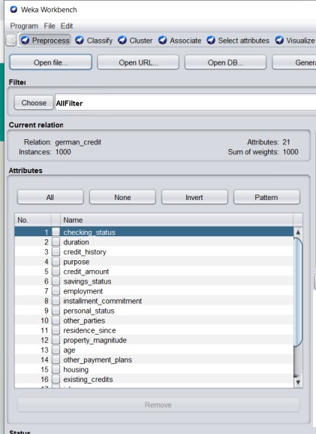 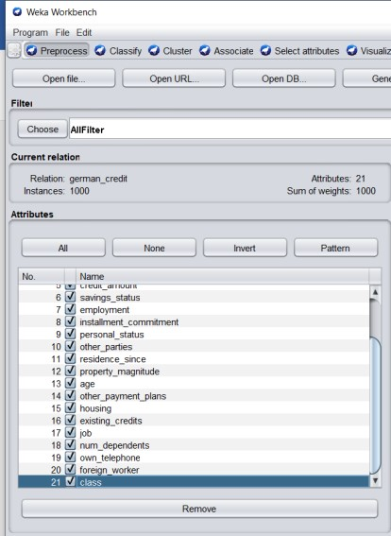

1. Number of attributes in dataset : 21

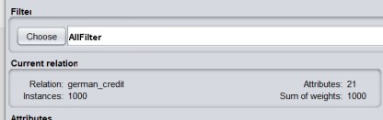

1. Number of records in dataset : 1000

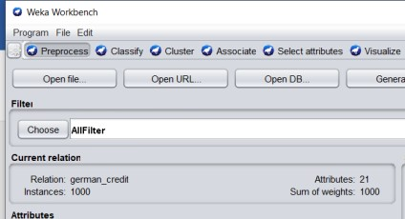

1. Class attribute in dataset : class

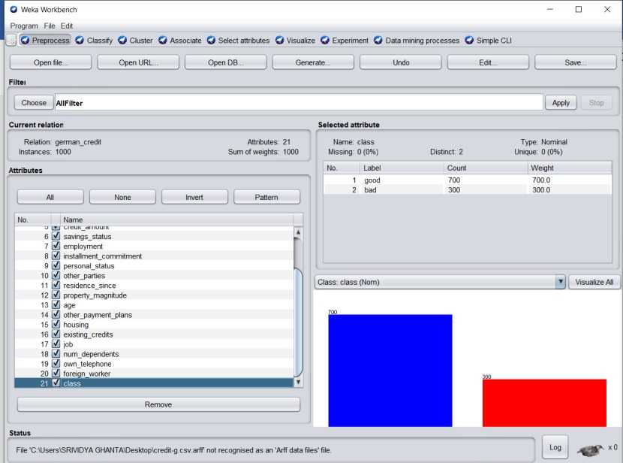

1. Number of attributes for each class:
   * Good – 700 records
   * Bad – 300 records

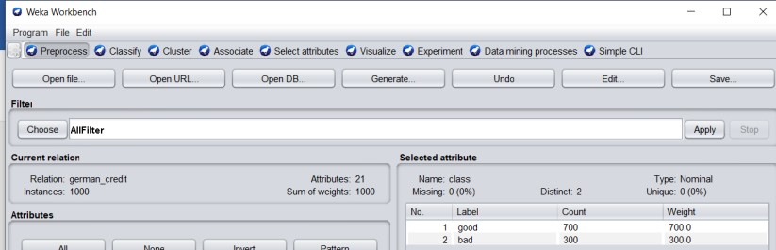

1. Graphical representation of all attributes :

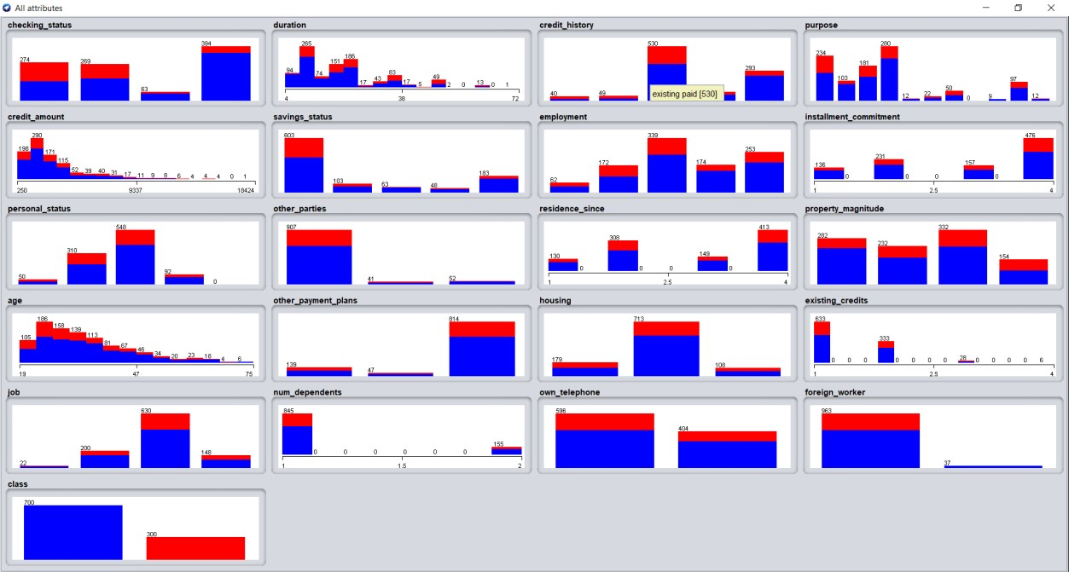

**ATTRIBUTES OF IRIS DATASET**

1. Attributes list and their type:
   * Sepallength – Numeric
   * Sepalwidth – Numeric
   * Petallength – Numeric
   * Petalwidth – Numeric
   * Class – Nominal

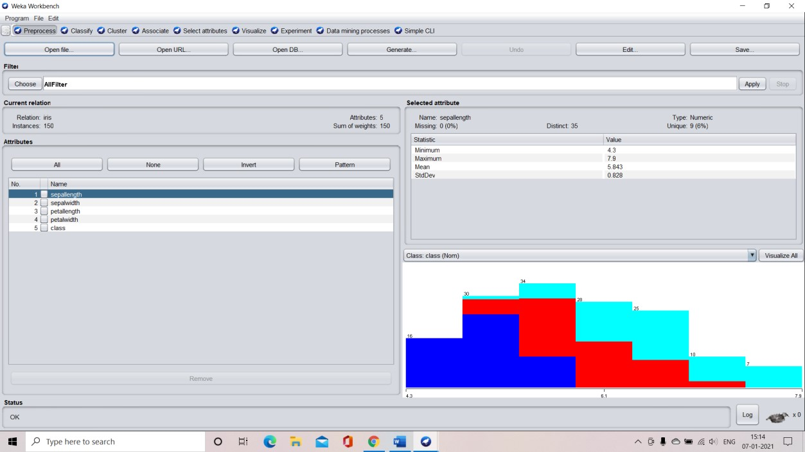

1. Number of attributes in dataset : 5

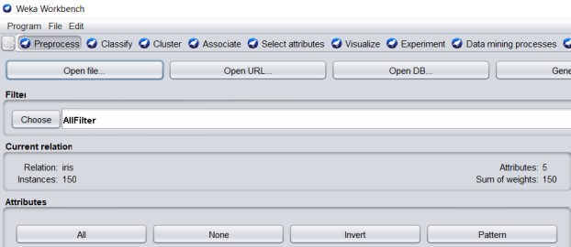

1. Number of records in dataset: 150

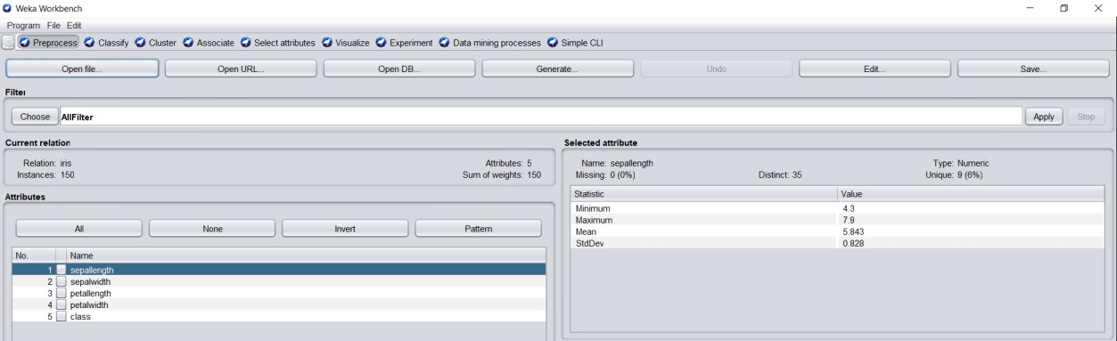

1. Class attribute in dataset – class

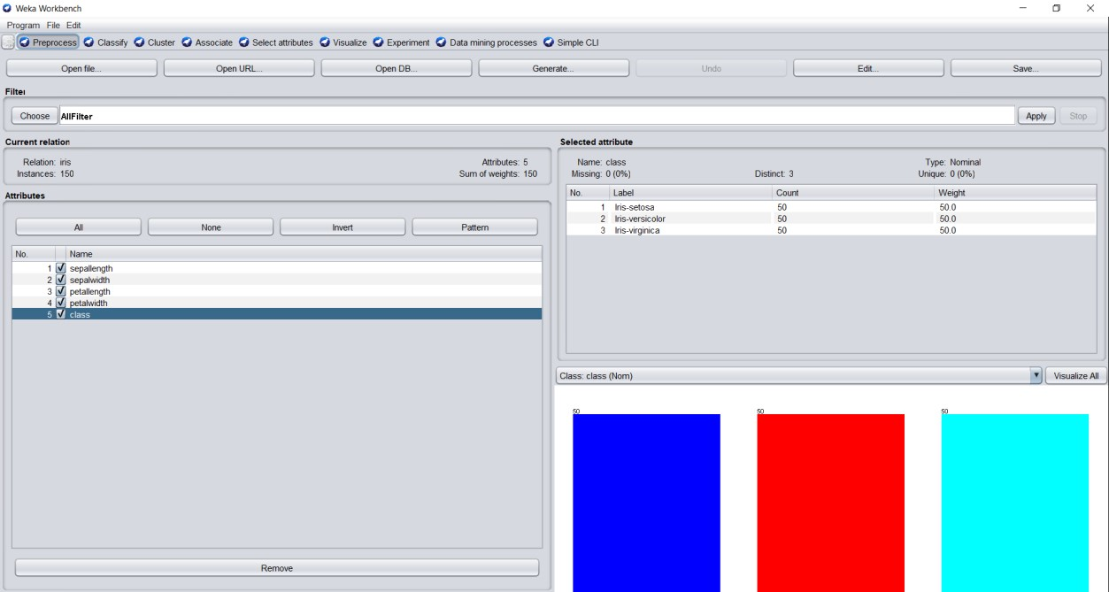

1. Number of records for each class:
   * Iris-setosa – 50
   * Iris-versicolor – 50 • Iris-verginica – 50

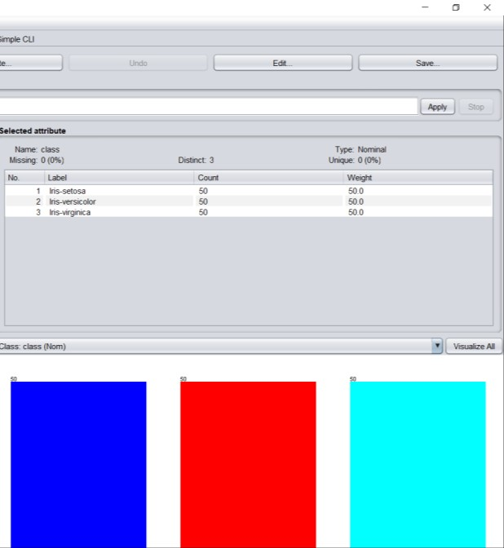

1. Graphical representation of all attributes:

